# Objective Questions:

***1. What is the total no. of tables present in the data?***

**Ans.** 3 Tables present in the data

i. Raw Data: Table consists of all the information about different restaurants all across the globe

ii. Country Description: Table consists of country codes of respective countries and currency conversion rate for changing currencies to Rs.

iii. Suggested countries: Table consists of all suggested countries and cities after performing analysis

***2. What is the total no. of attributes present in the data?***

**Ans.** There are total 27 attributes present in the data

1. Restaurant ID: Unique identifier for each restaurant.

2. Restaurant Name: The name of the restaurant.

3. CountryCode: Country code of the location where the restaurant is situated.

4. Country Name: The respective country for the given country code.

5. City: The city where the restaurant is located.

6. Address: The specific address of the restaurant.

7. Locality: The locality where the restaurant is situated.

8. Locality Verbose: Detailed information about the locality.

9. Longitude: The geographical longitude coordinate of the restaurant.

10. Latitude: The geographical latitude coordinate of the restaurant.

11. Cuisines: The type of cuisine offered by the restaurant.

12. Currency: The currency used for transactions in the restaurant.

13. Conversion Rates to Rs.: Currency conversion rates to Rs.

14. Has_Table_booking: Indicates whether the restaurant has a table booking option (Yes/No).

15. Has_Online_delivery: Indicates whether the restaurant offers online delivery (Yes/No).

16. Is_delivering_now: Indicates whether the restaurant is currently delivering (Yes/No).

17. Switch_to_order_menu: Indicates whether users can switch to the order menu (Yes/No).

18. Price_range: A numeric value indicating the price range category of the restaurant.

19. Votes: The number of votes or ratings/(feedback) received by the restaurant.

20. Average_Cost_for_two: The average cost for two people dining at the restaurant.

21. Average_Cost_for_two in Rs.: Average cost for two converted into Rs.

22. Rating: The overall rating of the restaurant is based on user reviews.

23. Datekey_opening: The date when the restaurant was opened.

24. Year: Extracted Year from Datekey_Opening column

25. Month: Extracted Month from Datekey_Opening column

26. Day: Extracted Day from Datekey_Opening column

27. Customized_price: Displays currency symbol and price together

***3. How many categorical columns are there in the data? [Search about categorical and continuous data, and try to answer this question]***

**Ans.** There are 14 categorical columns

1. Country Code

2. Country Name

3. City

4. Locality

5. LocalityVerbose

6. Cuisines

7. Currency

8. Has_Table_booking

9. Has_Online_delivery

10. Is_delivering_now

11. Switch_to_order_menu

12. Price Range

13. Votes

14. Rating

***4. The data consists of some inconsistent and missing values so ensure that the data used for further analysis is cleaned.***

**Ans.** I used below data cleaning process to make sure data is cleaned for further analysis

i.Column “Cuisines” has some missing values which has been filled with “Not Mentioned” in “Raw Data” sheet

ii. Columns “longitude” and “latitude” has inconsistent value “0”. We can delete the rows to enhance our data but I am keeping as it is because it is not affecting my analysis.

iii. Used Trim function to make sure there is no extra spaces in the data

***5. Using the LookUp functions, fill up the countries in the original data using the country code.***

**Ans.** I used “Country Code” from “Country Description” tab as my reference column to fill Countries in “Raw Data” tab using below formula.

**Formula:** =VLOOKUP($C2,'country description'!$A$1:$B$16,MATCH($D$1,'country description'!$A$1:$B$1,0),0)

**Column:** D

**Value in D2:** India

**Sheet:** Raw Data

***6. Create a table to represent the number of restaurants opened in each country.***

**Ans.** I used PIVOT table and selected “Country” in Rows and “Count of RestaurantID” in values to represent the number of restaurants opened in each country

**Sheet**: Pivot Tables and Charts

**Table Name:** 1. Total number of restaurants in each country

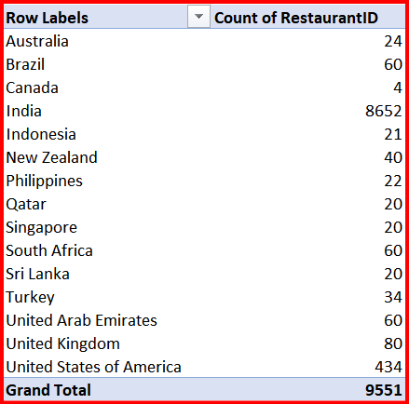

***7. Also, the management wants to look at the number of restaurants opened each year, so provide them with something here.***

**Ans.** I used PIVOT table and selected “Year” in Rows and “Count of RestaurantID” in values to represent the number of restaurants opened in each year

**Sheet:** Pivot Tables and Charts

**Table Name**: 3. Number of restaurants opened in each year

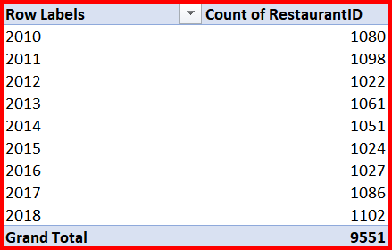

***8. What is the total number of restaurants in India in the price range of 4?***

**Ans.** I used PIVOT table and selected “Country” in Rows and “Count of Price_range” in values.

I used filter in “Country” and added a SLICER in “Price Range” to represent the number of restaurants in India with a price range of 4.

**Value:** 388

**Sheet:** Pivot Tables and Charts

**Table Name:** 4. Number of restaurants having price range of 4 in India

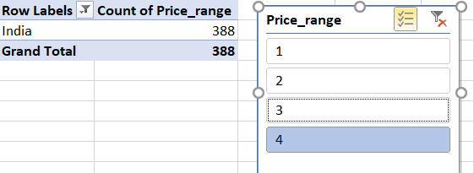

***9. What is the average number of voters for the restaurants in each country according to the data?***

**Ans.** I used PIVOT table and selected “Country” in Rows and “Average of Voters” in values to summarize the average number of votes by country, since only 1 voter can cast 1 vote. We can find the average number of voters per country.

The average number is rounded off to nearest whole number for simplicity.

**Observation:**

i. We can see that Indonesia has the highest number of voters 772 followed by United Arab Emirates 494 and Turkey 431.

ii. Brazil on the other hand has the least number of voters 20 after Singapore 32 and Canada 103.

**Table Name:** 6. Average count of voters in each country

**Sheet**:Pivot Tables and Charts

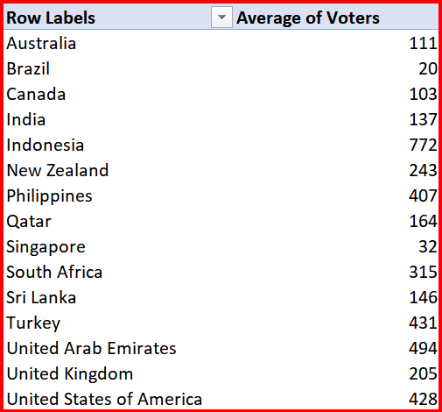

***10. In excel Calculate the average rating for all the restaurants that have price_range < 4 and provide online delivery. Use only the “IF” function, Logical Operators, and Aggregation functions to solve this problem. [Note: Don’t use Conditional aggregation in this question.]***

**Ans.** To solve the question without using conditional aggregation function, I have created a column (AB) which will return the rating if the condition ***price_range < 4 and provide online delivery*** passes and return 0 if condition fails.

**Formula used:** =IF(AND(O2="Yes", R2<4), V2, "0")

**Column:** AB

Then we can find the average rating for all the restaurants which passes the condition and round the value to 1 decimal place.

**Formula used:** =Round(average(AB:AB), 1)

**Column:** AD

**Value:** 3.3

**Sheet:** Raw Data

***11. Using Conditional formatting highlight the rows of restaurants that are located in the countries or cities that you’ve suggested to the management for opening new restaurants.***

**Ans.** Using conditional formatting I have highlighted the restaurants which are present in the countries I have suggested to open new restaurant.

1. Selected the restaurantname column

2. conditional formatting

3. New rule

4. Select Use a formula to determine which cells to format

5. Enter formula

i. =$D1="Australia"

ii. =$D1="Canada"

iii. =$D1="Singapore"

iv. =$D1="United Arab Emirates"

v. =$D1="United Kingdom"

6. Select format and choose colour to fill

**Column:** B

**Sheet:** Raw Data

***12. Create a new customized price column that consists of the abbreviation/symbol of the currency along with the Average_cost_for_two value. [Use string operations to do this task]***

**Ans.** I used MID() and FIND() and Concatenate as follows:

i. MID() extracts the sub-string from the given text based on starting and ending character number.

ii. FIND() returns the place where a certain character is situated in a string.

iii. Used FIND() to calculate the number of strings inside the “()” as some symbols are 1 character long while some are 3.

**Formula:** =CONCAT(MID(L2, FIND("(", L2) + 1, FIND(")", L2) - FIND("(", L2) - 1), " ", T2)

**Column L:** Currency and symbol together

**Column T:** Average_cost_for_two

**Column AA:** Customized_Price (Currency Symbol with Average_cost_for_two)

**Value in AA2:** Rs. 300

**Sheet:** Raw Data

***13. How can you create an array formula in Excel or Google Sheets to count the number of restaurants listed that do not offer online delivery, are in the lowest price range, and have an average cost for two people less than or equal to 250 Indian Rupees?***

**Ans. ARRAYFORMULA:** I have counted the number of restaurants that do not offer online delivery, are in the lowest price range, and average cost for two people is less than 250 Indian rupees. Using COUNTIFS function in cell AF1

**Formula**: {=COUNTIFS(O2:$O$9552,"No",$R$2:$R$9552,1,$U$2:$U$9552,"<=250")}

**Sheet:** Raw Data

**Column**: AF1

**Value:** 1694

# Subjective Question:

***1. Suggest a few countries where the team can open newer restaurants with lesser competition. Which visualization/technique will you use here to justify the suggestions?***

**Ans.** Countries I will suggest where new restaurants can be opened are

1. Australia

2. Canada

3. Singapore

4. United Arab Emirates

5. United Kingdom

The reason behind choosing these countries are mentioned below:

i. These countries are popular tourist destinations and there are very few counts of restaurants present in these countries which means there is less competition.

ii. There are very less number of restaurants opened in past few years

iii. Very less number of restaurants with high ratings (>4)

iv. Around 84%-85% of the restaurants do not have online delivery option and table booking option

I used Pivot Table, Slicers and Pie Chat for visualization.

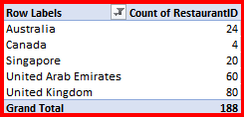 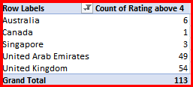 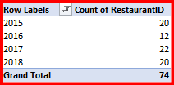 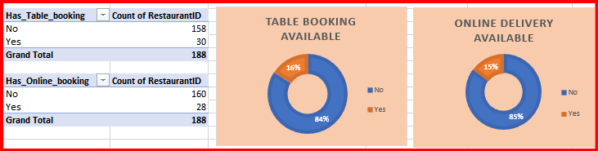

***2. Come up with the names of States and cities in the suggested countries suitable for opening restaurants.***

**Ans.** After selecting the countries where new restaurants should open, now we can analyse in which states and cities need to open new restaurants.

**Approach:** I have done below analysis to suggest in which city we can open new restaurants

i. Done analysis on which cities have less number of restaurants are suitable for opening new restaurants.

ii. Less number of restaurants having rating > 4.

iii. Max of the restaurants do not have online delivery option and table booking option

iv. There are very less number of restaurants opened in past few years

**Insights:** I have used pivot table, slicer and charts for visualization of cities in suggested countries

i. From the analysis I found that below mentioned cities have very less number of restaurants

ii. Very few restaurant having rating > 4 which means possibilities of opening new restaurants which can gain higher rating by their service, quality food and ambience

iii. 87% of restaurants do not have online delivery option and 78% don’t have table booking option. We can provide both online delivery and table booking option to reach more customers

iv. There are very less number of restaurants opened in past few years

**Suggested Cities:**

i. In Australia: Victor Harbor, Phillip Island, Lakes Entrance, East Ballina, Inverloch

ii. In Canada: Chatham-Kent, Consort, Vineland Station, Yorkton

iii. In Singapore: Singapore City

iv. In United Arab Emirates: Dubai, Abu Dhabi

v. In United Kingdom: Birmingham, London, Manchester

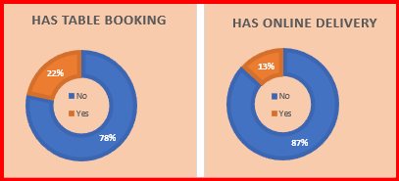 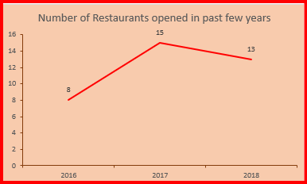

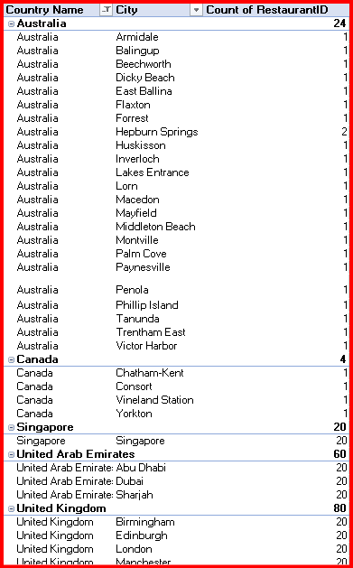 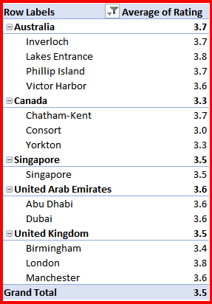

***3. According to the countries you suggested, what is the current quality regarding ratings for restaurants that are open there?***

**Ans.** I used PIVOT table and selected “Country” in rows and “Average of Rating” in values to show the average ratings for restaurants that are opened in my suggested countries by using filter in “Country”.

The average number is rounded off to 1 decimal for simplicity.

**Insights**: Rating plays a very vital role for restaurants by which customers decides weather to visit those restaurants or not.

i. Canada and Singapore has lowest average rating of 3.6 followed by Australia 3.7

ii. There is a possibility of getting high rating by providing high quality service, food and ambience to attract customers in our new restaurants

iii. Although United Arab Emirates and United Kingdom has more average rating of 4.2 and 4.1 respectively but the number of restaurants are very less in these countries.

**Table Name**: 7. Average rating of restaurants in each country

**Sheet**:Pivot Tables and Charts

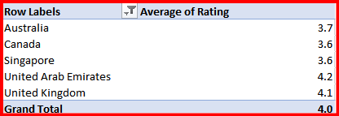 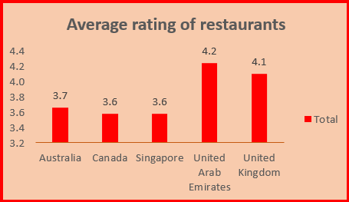

***4. Also, what is the current expenditure on food in the suggested countries, so we can keep our financial expenditure in control?***

**Ans.** I used PIVOT table and selected “Country” in rows and “Average of Average_cost_for_two in Rs.” in values to show the average cost for two in particular cuisine in my suggested countriesby using filter in “Country”.

**Analysis:**

i. To calculate the total expenditure on food, I have used a pivot table

ii. Countries in Rows and filter to suggested countries. Average of cost of two in Rs. as values.

**Insights**: We can see that Singapore has highest average expenditure for two i.e. Rs. 8442 followed by United Kingdom i.e. Rs. 4748 and Australia has the lowest average expenditure on food i.e. Rs. 1313 only.

**Table Name**:12. Average cost for two in cuisines for each country (in Rs.)

**Sheet Name:** Pivot Tables and Charts

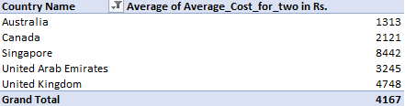 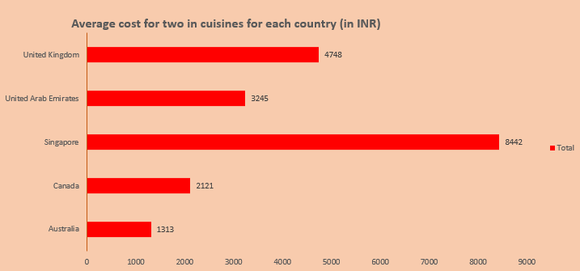

***5. Come up with the names of restaurants from the recommended states that are our biggest competitors and also those that are rated in the lower brackets, i.e. 1-2 or 2-3.***

**Ans.** I used PIVOT table and selected “Country”, “City” and “Restaurant Name” in Rows and “Average of Rating” in values.

I have added a slicer in “Rating” to show names of restaurants from the recommended cities that are high rated (i.e Rating >= 4) and also those that are rated in the lower brackets, i.e. 1-2 or 2-3.

**Insights:**

i. High rated (i.e. >=4) restaurants are our biggest competitors

ii. We need to keep our service, quality of food, ambience very high to compete with these restaurants

**Table Name:** 14. Competitor Restaurants and Low Rated Restaurants

**Sheet:** Pivot Tables and Charts

* The restaurants that are highly rated (i.e >=4) are our biggest compititors.

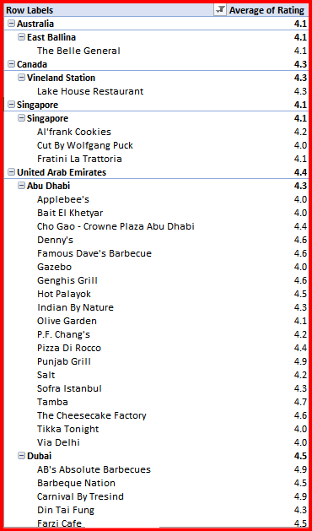 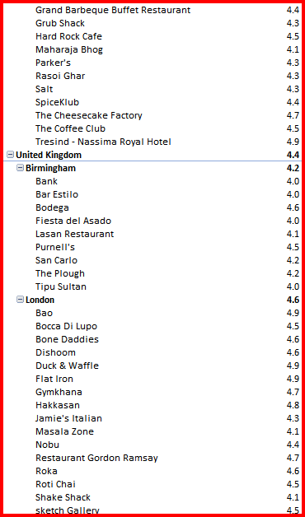

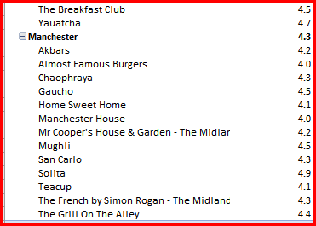

* Lower brackets (Rating 1-3) restaurants from my suggested cities are mentioned in the below pivot table.

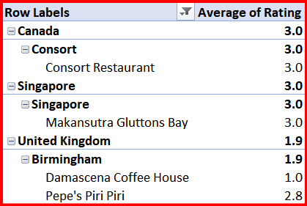

***6. Which cuisines should we focus on in the newer restaurants to get better feedback? Does the choice of cuisines affect the restaurant ratings?***

**Ans.** I have used Pivot Table and selected “Country”, “Restaurant Name” and “Cuisine” in Rows and “Average of Rating” in values

I have added a Slicer in “Rating” to focus on cuisines which are less rated (Rating 1-3) in other restaurants.

**Approach:** Cuisines which are less rated in other restaurants means there is a chance of less competition on selected cuisines and possibility of getting high rating in our restaurants.

**Insights:**

i. Yes, choice of cuisine does affect the restaurant rating as mostly locals like to eat the local cuisine the most.

ii. A cuisine depends on quality of ingredients used, flavour and cooking techniques used and presentation of food which can help to increase restaurants rating.

**Table Name:** 13. Low rated cuisines

**Sheet:** Pivot Tables and Charts

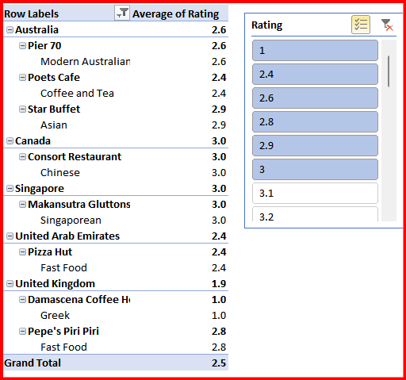

***7. According to our current data, should we go for online delivery and table booking? Does that affect the customer’s ratings?***

**Ans.** I have used 2 Pivot Tables and Donut chart to show percentage of restaurants having table booking available and has online delivery option

Yes, we should go for online delivery and table booking options it will help to handle heavy crowd and delivery will help to reach more customers.

**Insights:**

i. None of the restaurants in Australia, Canada and Singapore has table booking options and only 30% of restaurants has table booking options in United Arab Emirates and 15% in United Kingdom

ii. There are no restaurants which offer online delivery option in Australia, Canada, Singapore and United Kingdom and 47% restaurants have online delivery option in United Arab Emirates.

Yes, it will affect the customer rating to increase by easing them to book tables in advace when there will be heavy crowd and delivery will help to reach more customes than dine in customers.

**Table Name:** 8. Count of Restaurants Having Table Booking and Delivery Option

**Sheet:** Pivot Tables and Charts

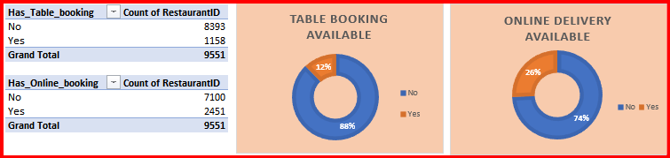

***8. Should the team keep the rate of cuisines higher? Will that affect the feedback? According to our data are the rates of cuisines and ratings, correlated?***

**Ans.** I use a scatter chart to show the correlation between restaurant ratings and Average of Average cost for two in Rs.

Yes, team can keep the rates higher keeping cuisine, service, ambience and quality of food high as we can see the average cost for two increases for high rated restaurants.

Yes, rate of cuisine and rating are correlated and shown in scatter chart below.

**Table Name**: 9. Corelation between cuisine price and rating

**Sheet**:Pivot Tables and Charts

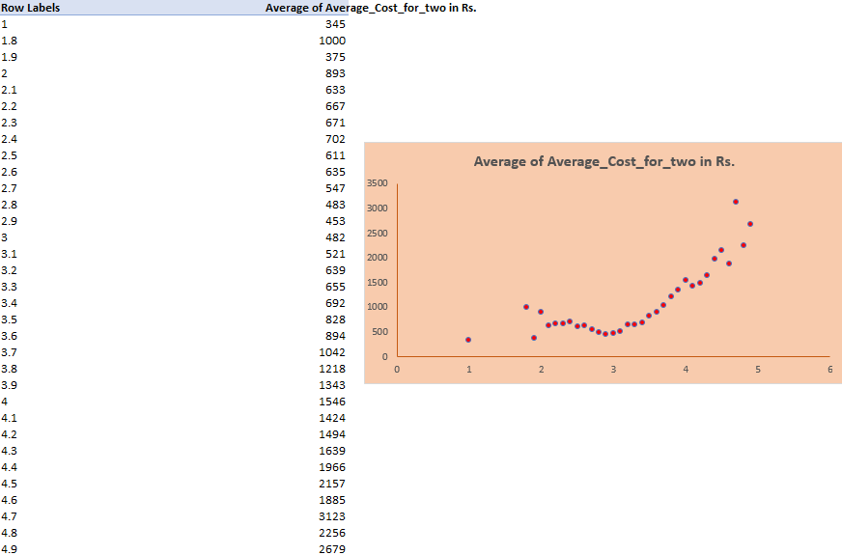

***9. What is the distribution of the number of restaurants of different price ranges in all the countries?***

**Ans.** To show the distribution of the number of restaurants of different price ranges in all the countries, I have created a pivot table taking “Price Range” in rows and “Count of Restaurantid” in values and used Pie Chart for vizualization.

**Insights:**

i.Most of the restaurants are in the price range of 1 i.e. 4444 which is 46% of total restaurants followed by count of restaurants in price range of 2 i.e. 3113 which is 33% restaurants.

ii. 1408 restaurants have a price range of 3 which is 15% of total restaurants.

iii. Very few restaurants have a higher price range of 4 i.e. 586 only which is 6% of restaurants.

**Table Name:** 11. Count of restaurants of different price ranges in all the countries

**Sheet:** Pivot Tables and Charts

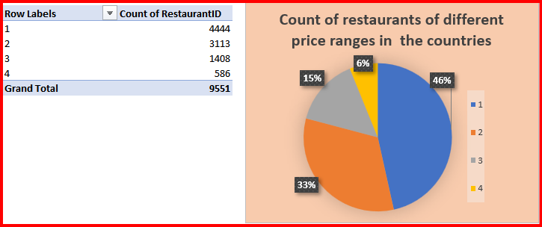

***10. Explain your approach in brief for suggesting countries/cities in order to open new restaurants, if the objective and subjective questions would have not been given to assist you. [you have to give bullet pointers in order to answer this question]***

**Ans.** Below are my approach for suggesting countries/cities in order to open new restaurants.

i. Short out countries which HAVE high population and are major tourist destination which have very less number of restaurants

ii. Divide the countries into states, cities and locality.

iii. Categorize cities and localities by standard of living

iv. Analyse cost for two in different rated restaurants and cuisines which are most popular in the area

v. Analyse price range of highly rated restaurants

vi. Check how many restaurants offer online table booking and delivery option

vii. Check how frequently new restaurant open in the cities and localities

# **THANK YOU**